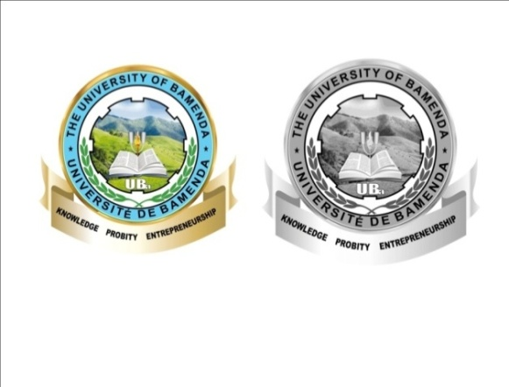
REPUBLIC OF CAMEROON
Peace – Work – Fatherland
*******
MINISTRY OF HIGHER
EDUCATION

THE UNIVERSITY OF BAMENDA
*******
RÉPUBLIQUE DU CAMEROUN
Paix – Travail –Patrie
*******
MINISTERE DE L’ENSEIGNMENT SUPERIEUR

UNIVERSITE DE BAMENDA
*******

{{SCHOO/FACULTY}}
DEPARTMENT OF{{DEPARTMENT}}
COURSE: {{COURSE_TITLE}}
COURSE CODE: {{COURSE_CODE}}
LEVEL: {{LEVEL}}

{{ASSIGNMENT_TITLE}}

PRESENTED BY:
{{STUDENT_NAME}}
Matricule Number: {{Matricule Number}}

Course Instructor
{{LECTURER’S NAME}}

{{ACADEMIC YEAR}}

